**D197 - Version Control Template**

***Step A Screenshot***

Below is a screenshot of the current repository graph in Gitlab after completing the steps in A:

***Step B Screenshot***

Below is a screenshot of the command line action after completing the steps in B:

***Step C Screenshot***

Below is a screenshot for each git command for each change made to the HTML files after completing the steps in C:

Below is a screenshot of the command line action after completing the steps in C:

***Step D Two Screenshots***

Below is a screenshot of the command line action after completing the steps in D:

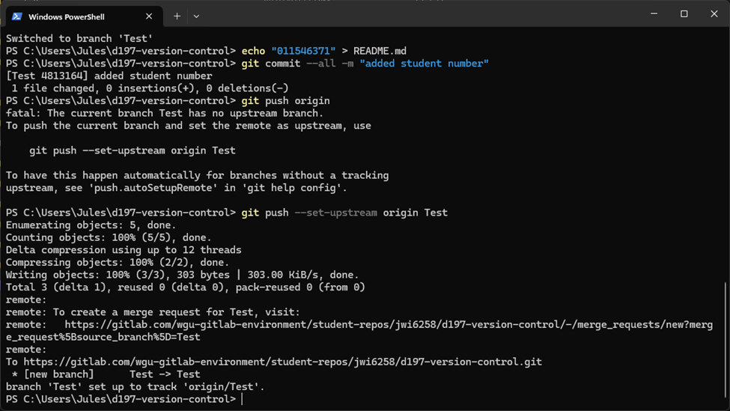

Below is a screenshot of the current repository graph in Gitlab after completing the steps in D:

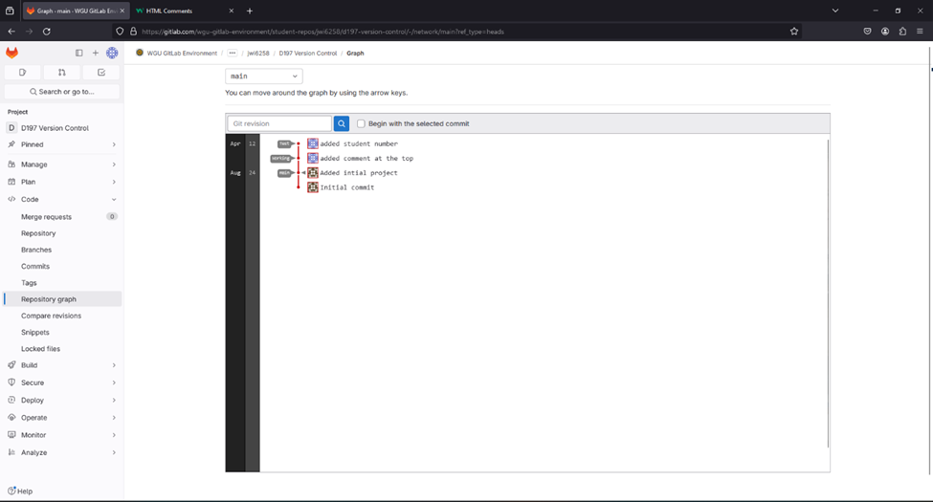

***Step E Two Screenshots***

Below is a screenshot that demonstrates the conflict of a merge command line action after completing the steps in E:

Below is a screenshot of the current repository graph in Gitlab after completing the steps in E:

***Step F Two Screenshots***

Below is a screenshot of the command line action after completing the steps in F:

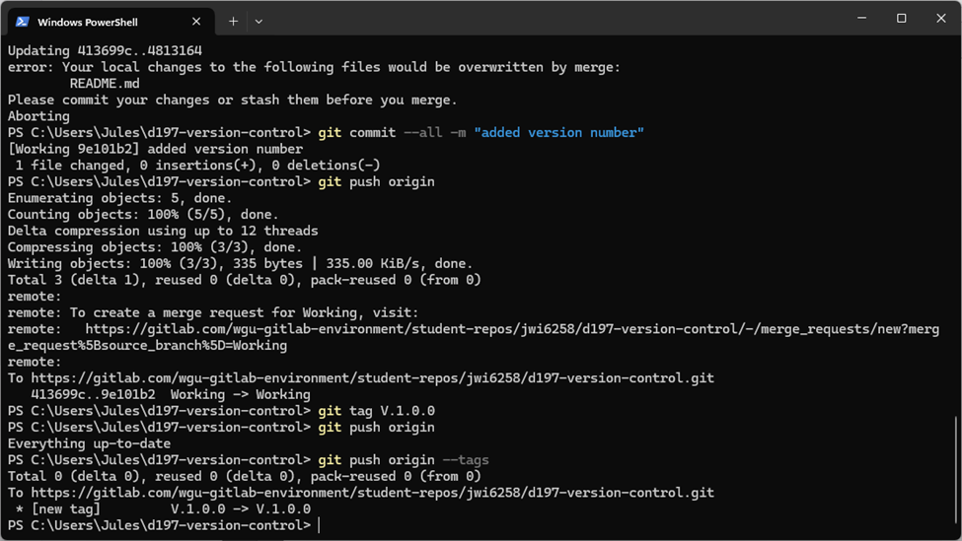

Below is a screenshot of the current repository graph in Gitlab after completing the steps in F:

